# **USING RAPTOR – COUNT AND PRINT VOWELS IN GIVEN WORD**

FLOWCHART

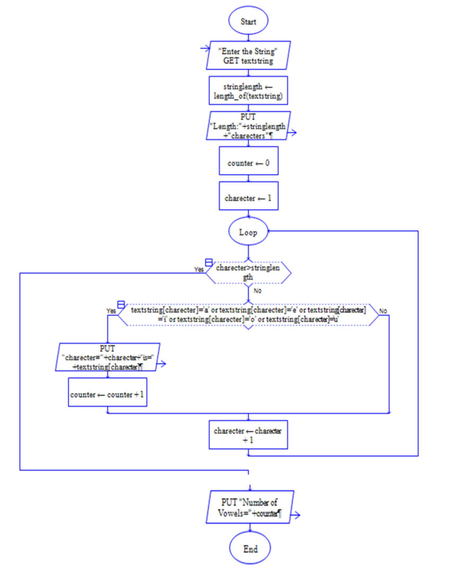

**OUTPUT**

INPUT IS sai srinivasreddy

**RESULT:**

The program is executed and verified successfully